AWS S3 EVENT TRIGGERING:

THE LAMBDA fucntions are triggered based on some events,
the event is creation of file into s3 bucket or uploading osme content into s3 bucket

so it is called event based triggering.

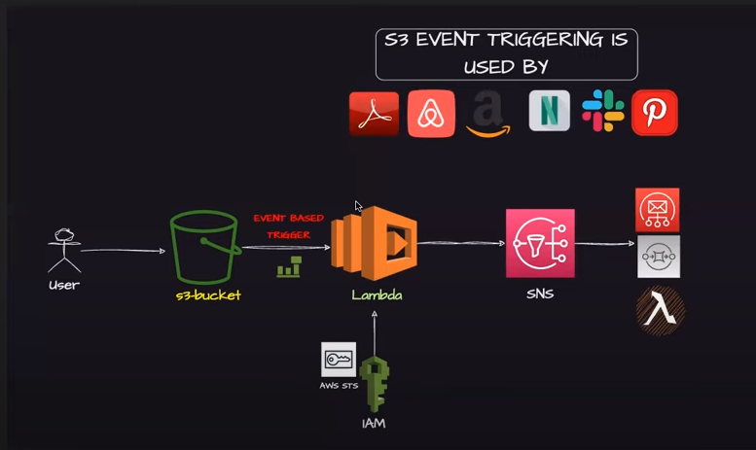
.

upload image into s3 service

LAMBDA is a serverless

if lambda completes execution in 3 seconds it will charge for only 3 seconds.
Lambda function needs to have the IAM, should have the permission to be invoked by the s3 bucket
and also to invoke the SNS

Using lambda we can sent email service using SNS

